English:
Following the Talk 6 programme, we will study biographies, looking at the life and times of Walt Disney, William Shakespeare and Katherine Johnson, amongst others. Class 6 will also be concentrating on the grammar requirements needed to create more complex sentences and stories.
Biographies.
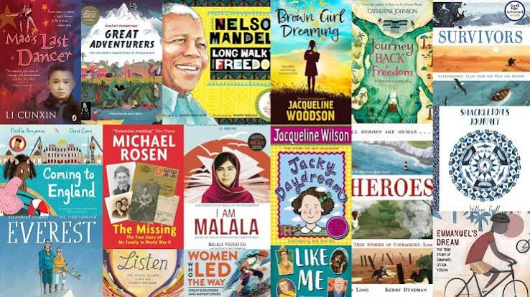
Maths:
Using the Red Rose Maths scheme for Year 6, the children will look at the following units:
Division
Fractions, decimals and percentages.
Algebra and sequences.
Geometry and Area.

Science: Properties and Changes of Materials.
Compare and group together everyday materials on the basis of their properties, including their hardness, solubility, transparency, conductivity (electrical and thermal), and response to magnets. Testing materials properties. Thermal Insulation – best material to insulate a hot drink/ best cup or best number of layers – skill focus setting up a fair test with some independence. Recap temp/thermometer skills, focus measuring temp change over time.

Geography:
Will be taught in Spring 1 term.
History: Athens and Sparta Ancient Greece –
A study of Greek life and achievements and their influence on the Western world.
How did leadership differ between city states in Ancient Greece?

RE: Prophecy and Promise.
In this unit, the children will explore how Christians understand Mary’s role in salvation history and she follows a tradition of women encountered in the Old Testament, who play a significant role in the history of ancient Israelites.

PE: Invasion Games – Rugby. Demonstrate passing and catching a rugby ball with consistency, accuracy and control. Pass and catch rugby ball with consistency, accuracy and control. Apply simple tactics when playing a rugby type game. Apply simple attacking and defending tactics when playing a rugby type game.

Dance: The Haka Share knowledge of the Haka. Learn the actions and words for Ka Mate Kaka. Focus on good timing and performing motif in unison.
PHSE:
Catholic school values- what do they mean for us and our behaviour?
Friendship week
MFL: We will introduce the children to the basics of the Spanish language, This term focusing on healthy lifestyles.
Art/DT:

Textiles – Stuffed toys.

Computing:
Creating media
Video editing – I Movie.
Music:
We will follow the Kapow scheme of work, this term focussing on the Blues..

